**Celect Plus** chip programming

1. Clean chips
2. Get ECM serial number
3. Convert number to HEX with 6 digits
   * example s/n 512221 in hex is 7D0DD
   1. Check what part number you need
   2. Find folder to your correct partnumber ex: 6662 , 8300 ,8303
   3. Program serial number on XICOR X28C64
      * at hex address shown below with AA AA AA place holders

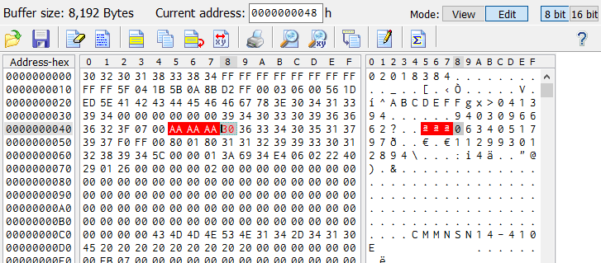

* 1. Blank the other two flashes ex: AN28F512